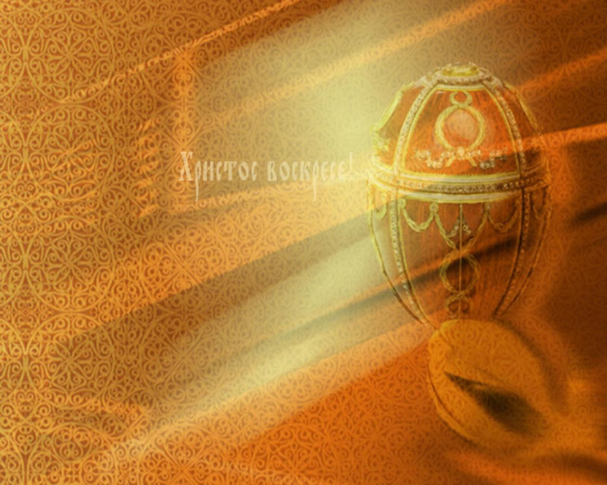
Easter

In Great Britain!

Easter is a very popular holiday in Great Britain. At Easter the British celebrate the idea of the new birth by giving each other chocolate Easter eggs, which are opened and eaten on Easter Sunday. On Good Friday bakers sell hot cross buns. Easter Monday is a holiday and many people travel to the seaside for the day or go and watch one of the many sporting events as football or horse racing. Egg-rolling is a traditional Easter pastime which is still popular in Northern England, Scotland, Wales and Isle of Man. It takes place on Easter Sunday or Monday, and consists of rolling colored, hard-boiled eggs down a slope until they are cracked and broken after which the players eat them. In some parts of Britain, the competitions take place and the winner is a player whose egg remains longest undamaged, but usually the fun is just rolling and eating. This is the older form of the custom, since egg-rolling does not appear to have been a game to be lost or won.

In Russia!
Easter in Russia is the most important holiday of the year. Preparation for Easter starts seven weeks ahead of time with the advent of Lent. Believers don’t eat meat and animal products. Palm Sunday, the week before Easter, is known as Willow Sunday. People bring home willow branches which have been blessed in church. The week is dedicated to preparing for Easter. The Thursday before Easter is called Clean Thursday. According to the tradition one should bathe before sunrise on this day. The house must be clean too. Good Friday is the day that the women of the family bake “paska”, Easter bread. On Saturday children dye Easter eggs to add to the Easter basket which will be blessed in church. It also includes pysanka, salt, paska, sausage and ham. In the evening people go to church for the Easter mass, which lasts all night. Easter Sunday is a day of singing songs and eating. Young girls dance and sing about nature and spring.

